Jquery tempates

http://stephenwalther.com/archive/2010/11/30/an-introduction-to-jquery-templates

<script type=”text/javascript” src=”http://ajax.aspnetcdn.com/ajax/jQuery/jquery-1.4.4.js”></script>

<script type=”text/javascript” src=”http://ajax.aspnetcdn.com/ajax/jquery.templates/beta1/jquery.tmpl.js”></script>

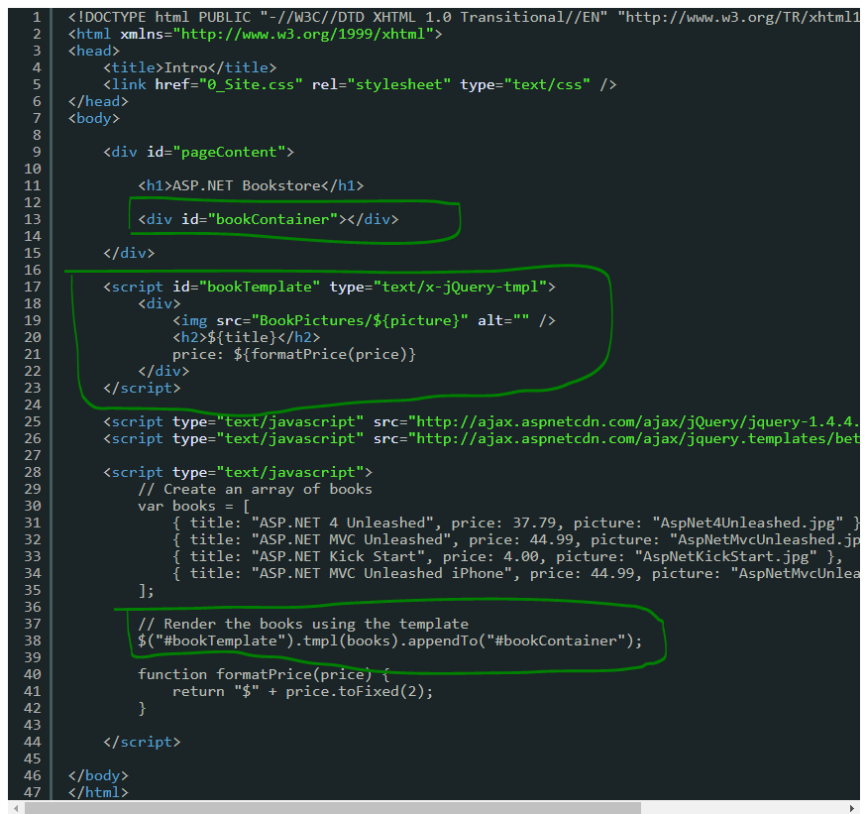

The following page illustrates how you can use the { if}} and {{each}} template tags to conditionally display categories for each blog entry:

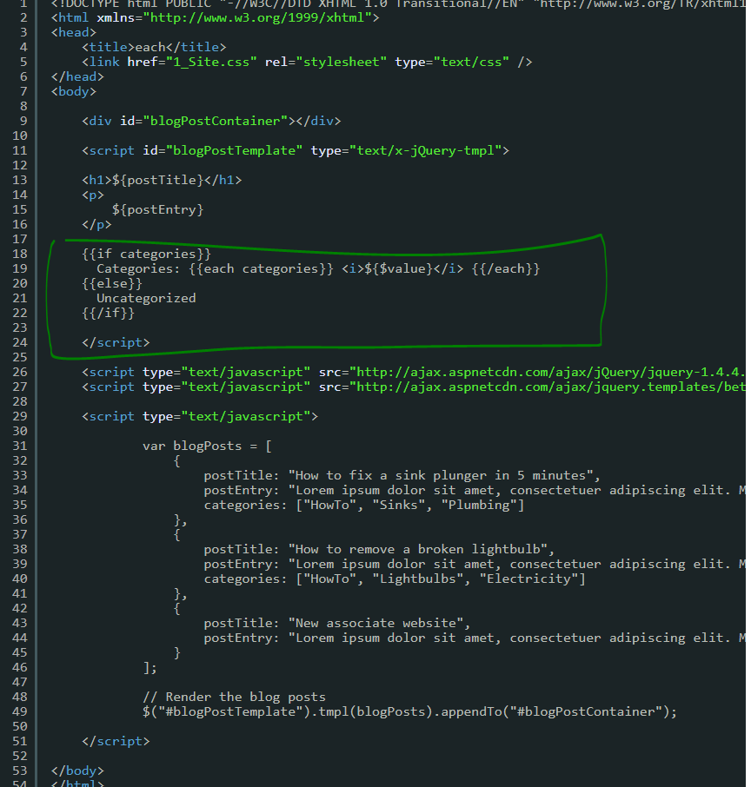

you might want to build a template out of multiple templates. In other words, you might want to take advantage of template composition.

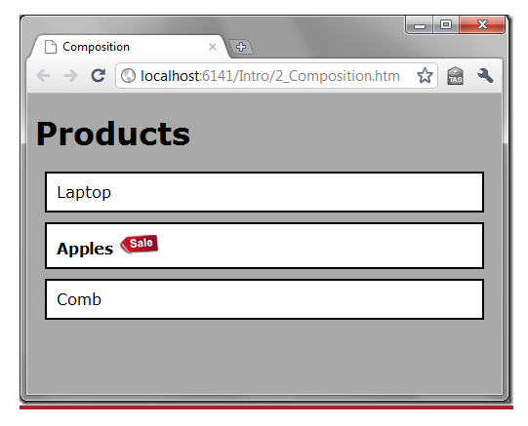

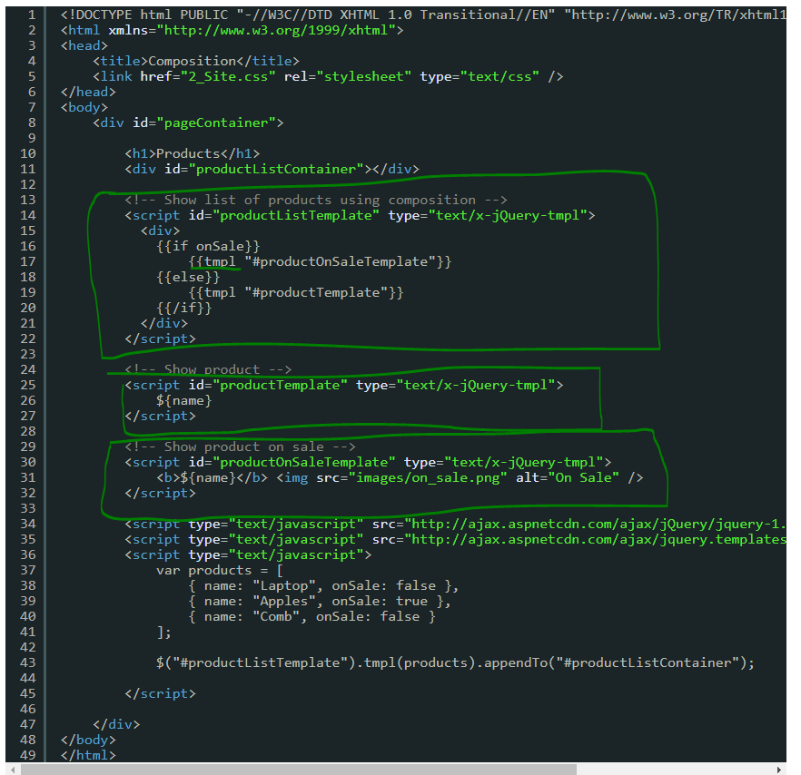

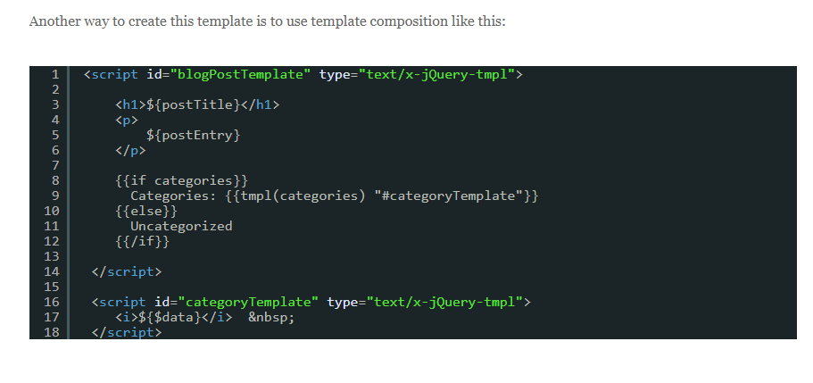

The {{wrap}} template tag enables you to take a chunk of HTML and transform the HTML into another chunk of HTML (think easy XSLT)

The first template contains the HTML being transformed and the second template includes the filter expressions for transforming the HTML.

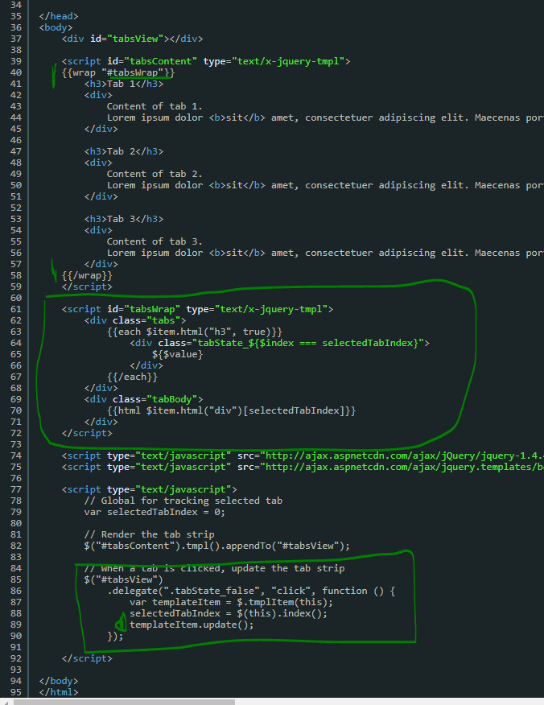

Remote Templates

A common feature request for jQuery templates is support for remote templates. Developers want to be able to separate templates into different files.

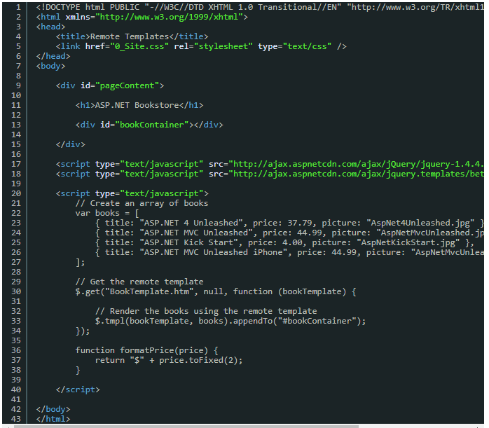

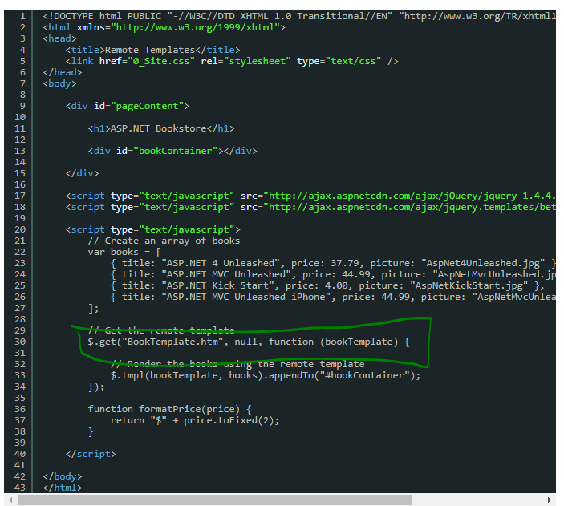

This is BookTemplate.html:

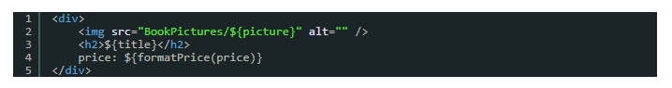

If you plan to use the bookTemplate multiple times – for example, you are paging or sorting the books — then you should compile the template into a function and cache the compiled template function.